Vision Brainstorm Exercise

Why It’s Important
Your vision statement guides every decision you make about your business. It’s the goal every department is working towards.

Expectations of First Draft
Don’t worry, this may not be poetry and it might not be your “forever vision” but it will get you in the right direction and start you thinking about it strategically.
Starting out, the best outcome is that this vision statement aligns everyone in the organization to a common goal. This takes practice and needs to be constantly reinforced from the top down and through each other.

Before You Begin…
Before you start brainstorming, think about the following questions:
- Do you want to get acquired?
- Why was the company started?
- What are your core values?
- Why do customers buy from you instead of your competitors? What do they like most about you?
- What is it about the culture that makes it a great place to work?
- Why do your most dedicated employees stay?

Exercise
Keep thinking about the questions above as you brainstorm concepts for each section below. You don’t need to put it into one sentence at this stage, just get the concepts documented.
Measurable  How would we know if progress is being made? What things can you measure 5, 10+ years from now to know you’ve reached your vision? | [Brainstorm here]  Examples:  - Average order value is $XXX.  - Work with the top 10 target customers in the country.  - Profit margin at 15%.  - 3-month waiting list.  - $120M acquisition offer from XYZ company.
Attainable  Must be able to take it seriously. While we want a lofty goal, it needs to be realistic, or it won’t be taken seriously. | [Brainstorm here]  Bad Examples:  - Our CEO will be the next Shark on Shark Tank (I suppose it could happen, but you get the idea).  - Elon Musk will make a statement to Forbes that he couldn’t have done it without us.
Inspiring  Must engage people emotionally. If you want the entire company to gear up to accomplish something, it needs to motivate. | [Brainstorm here]  Examples:  - We are picky about our customers; only working with the best fit customers.  - Our solution will be the new standard for XYZ industry.
Cultural  Must fit within the organization’s unique style. When you present your vision to the company it should feel authentic and not out of left field. | [Brainstorm here]  Clarification Notes:  - If you make B2B software and want to double your revenue, it would be weird to try to double your revenue by launching a line of athletic shoes.  - If your core values are quality and integrity, then it would be off-brand to reach your revenue goals by cutting corners to decrease costs.  - If you’re known as an all-American brand it would be out of left field to outsource a large portion of your operation overseas.
Single-Minded  Must be focused. We’re not talking about a run-on sentence with a lot of goals. It needs to be one goal…your best and biggest goal. | [Brainstorm here]  Clarification Notes:  - Avoid “and” in your statement. The vision needs to be focused.  - Don’t try to squeeze everyone’s opinion into the vision.  - Don’t focus on the exact words, focus on the core concepts; don’t spend time debating the words.
Vivid  Must be clear and easily understood. If your vision is written with a bunch of jargon, it’s not going to be clear, and no one will know how to get there. Keep it simple. | [Brainstorm here]  Bad Examples:  - Undisputed marketplace leadership.  - Our goal is to provide the highest level of service, the broadest selection of products and the most competitive prices.  - Be the most successful XYZ company in the world at delivering the best customer experience in markets we serve.

Drafting Your Statement
Now it’s time to draft a statement as simply as you can that encompasses the heart of the brainstorm above. It should be a statement the entire company can rally around.
Please remember, it should be simple and clear what you’re trying to do. It doesn’t have to be perfect.
To start, try answering these questions:
- What do you want to achieve in 5 or 10 years?
- How do you want to achieve it? What do you want to do in order to achieve it?

Example of Putting it All Together

Sample summary:
Example: Company that makes project management software
What: We want to be able to brag about working with 20% of the Global Fortune 2000
How: Be part of their project management tech stack

Vision statement:
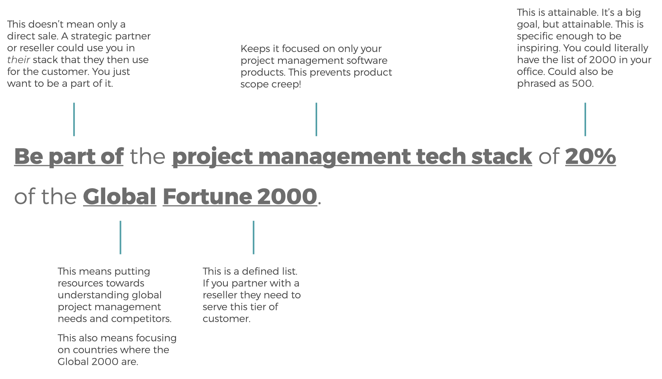

Does this meet our criteria for a good Vision statement?
Yes, it does!
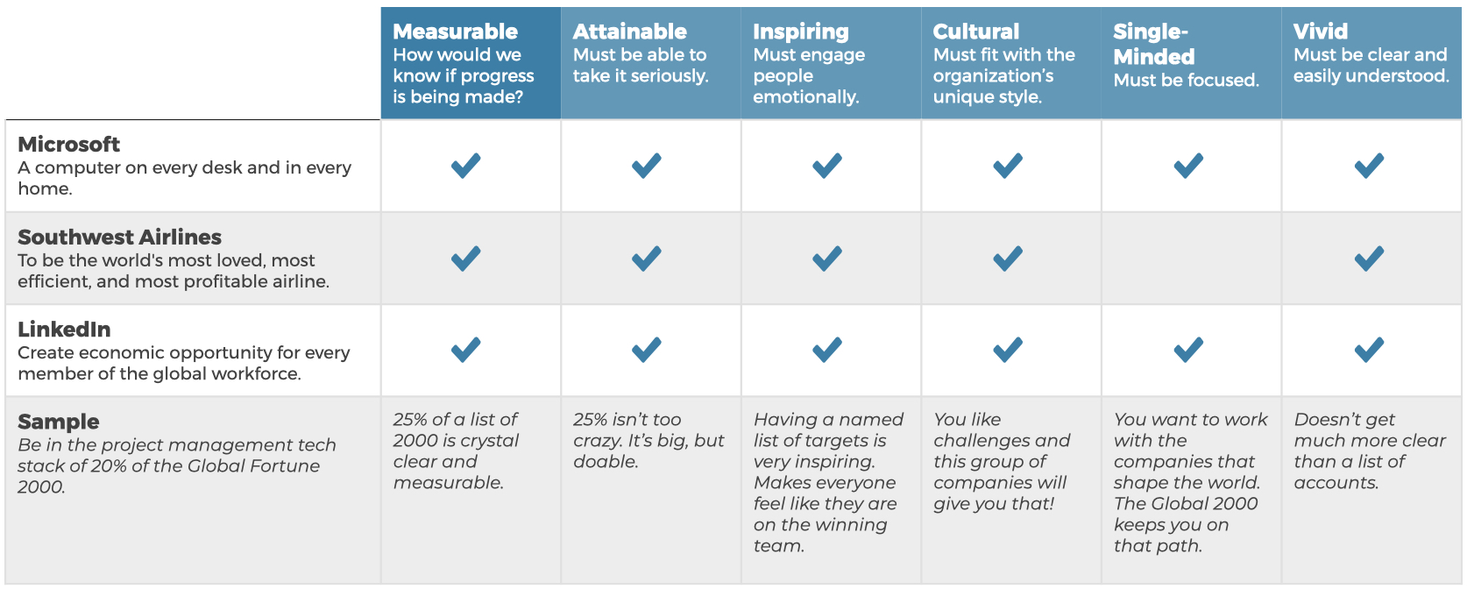

Now Draft Your Vision Statement:
What we do: Company that makes [XYZ]
What: We want [what you want to achieve]
How: [How you want to achieve it]
Statement draft:
Achieve ___________________________________________________________________________(what)
by doing___________________________________________________________________________ (how).
Check your work:
Does your draft meet all six criteria for a good vision statement?
Measurable:
Attainable:
Inspiring:
Cultural:
Single-minded:
Vivid:

Share Your Vision!
Don’t let your vision sit in a desk drawer. Here are some ways other clients have shared their vision with the rest of the company.
- Presentation during sales kick-off or an all-hands meeting.
- Swag boxes for all employees.
- Mural in the office with the vision or as in our example, a list of the Global Fortune 2000 as a reminder of their target audience.
- Thermometer graphic on office monitors tracking progress to the vision.
What other ways can you think of to get buy-in company-wide for your vision?

How to Use Your Vision to Make Decisions
Your vision is meant to be referenced and used constantly to make sure you’re on track. For every decision you and your employees make, ask these two questions. It’s simple, but not easy. Ask these questions for everything from whether to hire someone to what conferences you should go to.
When used correctly, it will keep your tactics lean and focused.
